STERLING E-COMMERCE CUSTOMER BEHAVIOR ANALYSIS REPORT

3MTT Data Analytics Project
Tool Used: Microsoft Power BI
Prepared by: Oyeleye Shina
Date: 15th January, 2026
1. Introduction
E-commerce platforms generate large volumes of transactional data that can provide valuable insights into customer behavior and business performance. Understanding how customers shop, which products they prefer, how they pay, and where demand is concentrated is essential for effective decision-making.
This project analyzes Sterling’s e-commerce transaction data to understand customer shopping behavior. Using Power BI, the data was cleaned, modeled, analyzed, and visualized to identify purchasing patterns, preferred payment methods, high-demand product categories, and top-performing locations. The insights generated from this analysis support data-driven business decisions.
2. Project Objectives
The main objectives of this project are to:
- Understand customer shopping behavior using e-commerce data
- Identify product categories with the highest demand
- Analyze customer payment method preferences
- Evaluate order distribution across cities and locations
- Examine customer order frequency and demand trends over time
- Provide actionable business recommendations based on insights
3. Dataset Description
The dataset used in this project contains Sterling’s e-commerce transaction records. Each row in the dataset represents a single customer order. The key variables include:
- Customer ID – Identifies individual customers
- Product Category – Type of product purchased
- Quantity Ordered – Number of items purchased per order
- Payment Method – Mode of payment used by the customer
- Order Date – Date when the order was placed
- City / County – Customer location
The dataset supports analysis of customer behavior, product demand, payment preferences, and geographic performance.
4. Data Cleaning and Preparation
Data preparation was carried out using Power Query in Power BI to ensure accuracy and reliability of the analysis. The following steps were performed:
- Removal of duplicate records
- Verification and correction of data types (dates, text, numeric fields)
- Review and handling of missing or inconsistent values
- Renaming of columns for clarity and readability
- Creation of a dedicated Date table to enable proper time-based analysis
- Establishment of a one-to-many relationship between the Date table and the order date
Key analytical measures were created using DAX, including:
- Total Orders
- Total Customers
- Total Quantity Ordered
- Orders per Customer
These steps ensured the dataset was clean, structured, and suitable for professional analysis.
5. Data Analysis Methodology
The analysis was conducted using descriptive analytics techniques to summarize and explore customer behavior patterns. The following approaches were applied:
- Aggregation of orders and quantities using DAX measures
- Grouping of data by product category, payment method, and location
- Time-based analysis using a Date slicer and line chart
- Interactive filtering to explore trends across different periods
Power BI visuals were carefully selected to match each business question, ensuring clarity and effective communication of insights.
6. Dashboard Overview
An interactive Power BI dashboard titled “Sterling E-Commerce Customer Behavior Dashboard” was developed. The dashboard includes:
- KPI Cards showing Total Orders, Total Customers, Total Quantity Ordered, and Orders per Customer
- Date Slicer allowing users to filter analysis by specific time periods
- Bar and Pie Charts for category, payment method, and city-level comparisons
- Line Chart to analyze demand trends over time
- Customer Summary Table to support detailed and interactive exploration

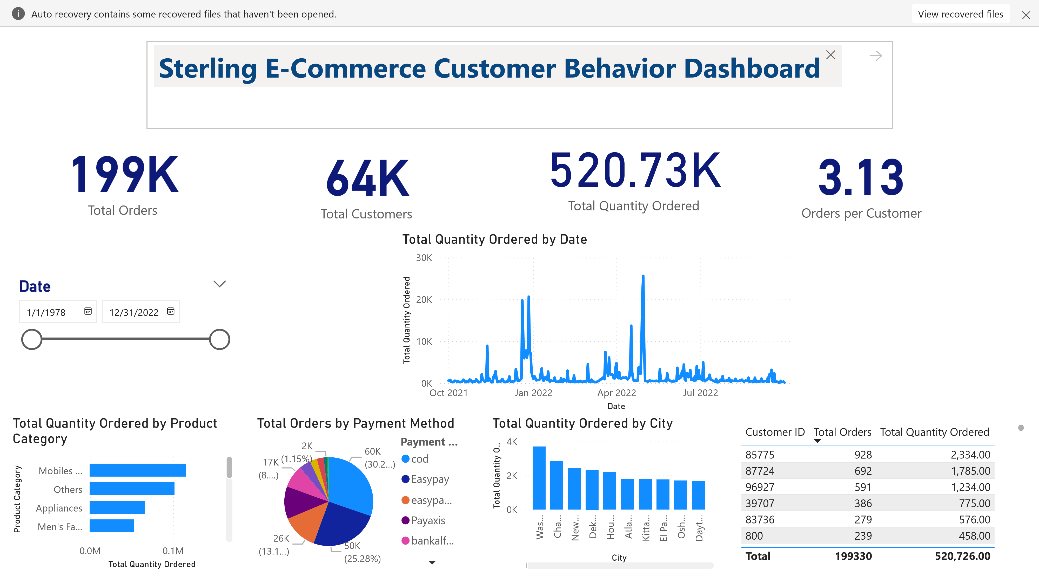
The dashboard allows users to dynamically explore the data and gain insights efficiently.
7. Key Insights
The analysis revealed several important insights:
- Certain product categories record significantly higher quantities ordered, indicating strong customer demand in those categories.
- Digital payment methods such as card and bank transfer are the most preferred, showing customer confidence in electronic payment systems.
- Orders are heavily concentrated in major cities, suggesting higher purchasing power and market penetration in urban locations.
- The average number of orders per customer indicates repeat purchasing behavior, reflecting positive customer engagement.
- Demand trends over time show fluctuations, which may be influenced by seasonal factors, promotions, or market conditions.
8. Business Recommendations
Based on the insights obtained, the following recommendations are proposed:
- Increase inventory levels and marketing focus on high-demand product categories to maximize sales opportunities.
- Strengthen and optimize popular digital payment channels to improve customer experience and transaction efficiency.
- Implement targeted marketing campaigns and improved logistics services in high-performing cities.
- Introduce customer loyalty programs or incentives to encourage repeat purchases and improve customer retention.
- Use trend analysis to plan promotions and sales strategies during periods of high demand.
9. Conclusion
This project demonstrates how e-commerce data can be transformed into meaningful insights using Power BI. Through effective data cleaning, modeling, analysis, and visualization, customer behavior patterns were successfully identified. The insights generated provide valuable guidance for improving product strategy, payment systems, customer engagement, and location-based marketing.
Overall, the analysis highlights the importance of data-driven decision-making in enhancing business performance and customer satisfaction.
10. Tools Used
- Microsoft Power BI – Data cleaning, modeling, analysis, and visualization
- Power Query – Data preparation
- DAX – Creation of analytical measures

